**PRODUCTIVITY WEB(FOCUS)**

**Use Case, Class and Sequential diagrams for the project.**

**GROUP-9**

Nimmala Sai Bhargav (21114067)

Nenavath Suresh Kumar (21114066)

Taddi Satya Shyam Sundar (21114102)

Sapavath Yashwanth Krishna (21114093)

Aditya Singh (21114006)

Sani Shashi praneeth (21114089)

1. **USE CASE MODEL**

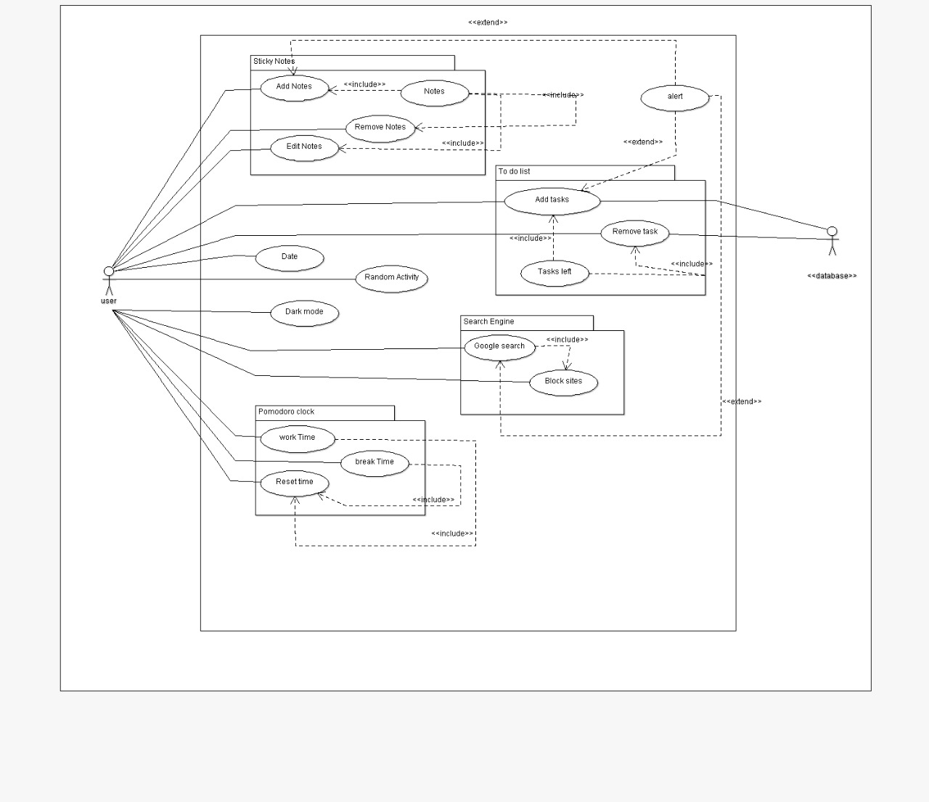

**U1: Add tasks:** Using this use case, the user can add some tasks to be done.

**Scenario 1**: Mainline sequence

1. User: Select Add tasks option.

2. System: Displays the added tasks.

**Scenario 2:** At step-1 of Mainline sequence

2. System: Displays a message to add atleast one task.

**U2: Remove tasks:** Using this use case, the user can remove unwanted tasks.

Mainline sequence

1.User: Selects Remove tasks option.

2. System : Displays the only tasks left.

**U3: Add Notes:** Using this use case, the user can add some notes .

**Scenario 1**: Mainline sequence

1. User: Select Add Notes option.

2. System: Displays the added notes.

**Scenario 2:** At step-1 of Mainline sequence

2. System: Displays a message to add atleast one note.

**U4: Remove Notes:** Using this use case, the user can remove unwanted notes.

Mainline sequence

1.User: Selects Remove notes option.

2. System : Displays the only notes left behind.

**U5: Google Search**: Using this use case, the user can search on web.

**Scenario 1:**Mainline sequence

1. System: Displays a prompt to enter the url.

2. User : Types required url and enters search option.

3. System: Opens the url in the web.

**Scenario 2**: At step-2 of mainline sequence

3.System: Displays a message to enter valid url.

**U5: Random activity**: Using this use case, the user can get random activities when he is bored.

**Scenario 1**: Mainline sequence

1. User: Selects random activity option.

2. System : Displays random activity.

**U6: work time**: Using this use case, the user can start the timer.

**Scenario 1**: Mainline sequence

1. User: Selects the start option.

2.System: Runs the pomodoro clock until the timer ends.

**U7: Reset time**: Using this use case, the user can modify the time.

**Scenario 1**: Mainline sequence

1. User: Selects reset work time option or break time option and modifies it.

2. System : Displays the modified time.

U8: **Darkmode**: Using this use case, the user can change the background colour to black when he gets his eye strained.

**Scenario 1**: Mainline sequence

1. User: Selects the darkmode option.

System: Displays the background colour in black.

1. **UML CLASS DIAGRAM**

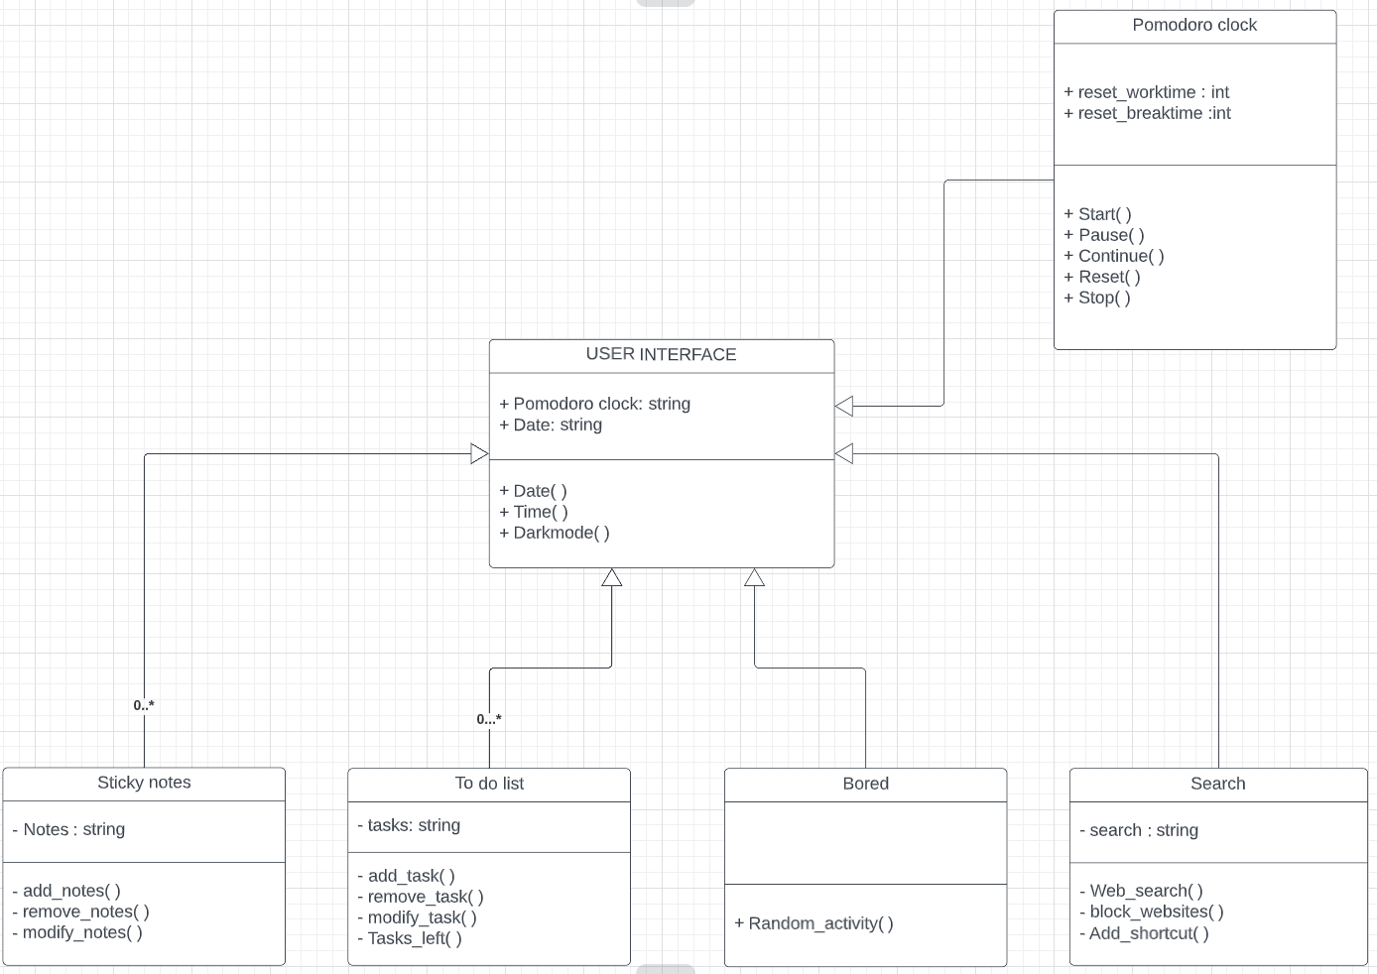

**CLASS DIAGRAM DESCRIPTION**

**1. USER INTERFACE**

**FUNCTIONS:**

**• Date( )**

**• Time( )**

**• Dark mode( )**

**2. TO do list**

**VARIABLES:**

**• tasks**

**FUNCTIONS:**

**• add_tasks( )**

**• remove_tasks ( )**

**• modify_tasks( )**

**• Tasks_left( )**

**3. Sticky notes**

**VARIABLES:**

**• notes**

**FUNCTIONS:**

**• add_notes( )**

**• remove_notes( )**

**• modify_notes( )**

**4. Search**

**VARIABLES:**

**• search**

**FUNCTIONS:**

**• Web_search( )**

**• Block_website( )**

**• Add_shortcut( )**

**5. Bored**

**FUNCTIONS :**

**• Random_activities( )**

**6. Pomodoro clock**

**VARIABLES:**

**• reset_worktime**

**• reset_breaktime**

**FUNCTIONS:**

**• Start( )**

**• Pause( )**

**• Continue( )**

**• Reset( )**

**• Stop( )**

**III. UML SEQUENCE**

**DIAGRAMS**

* **Search**

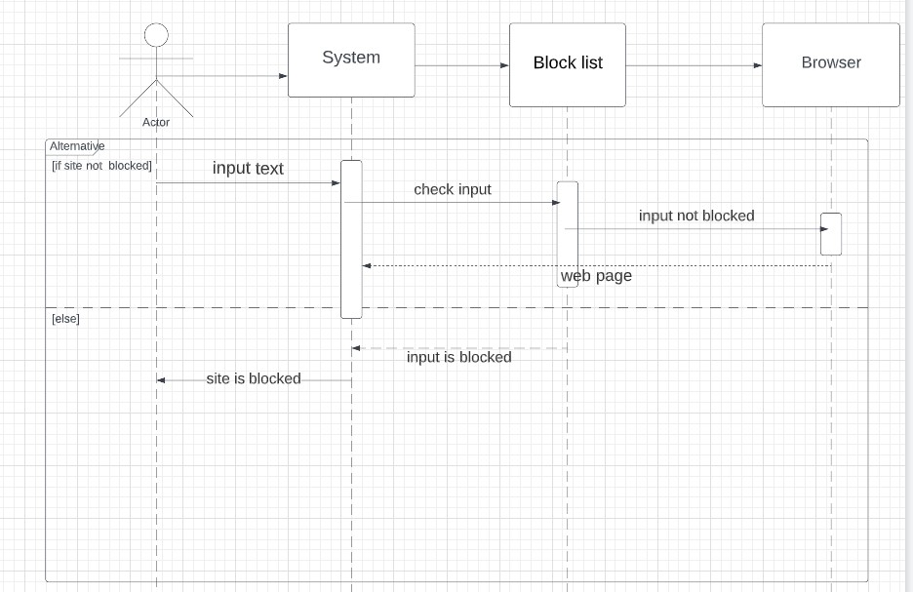

* **Notes**

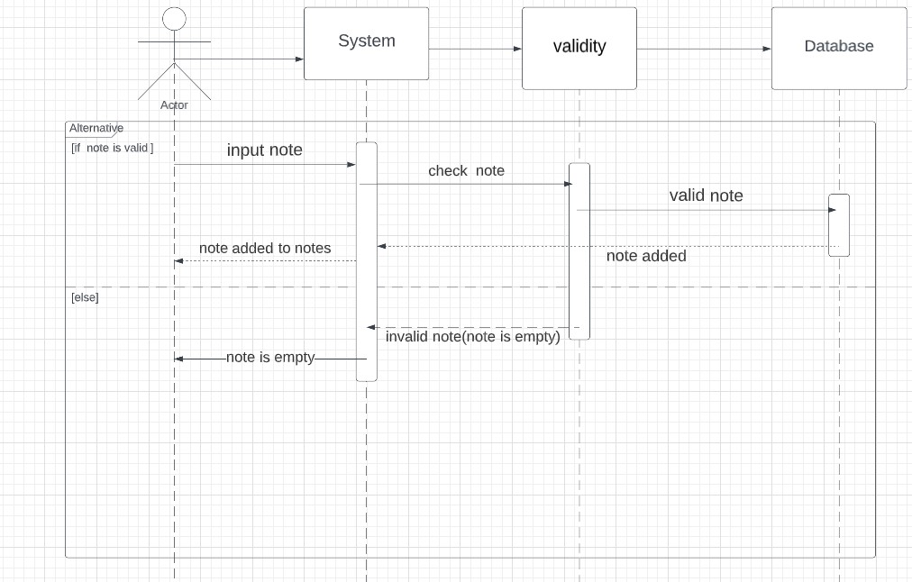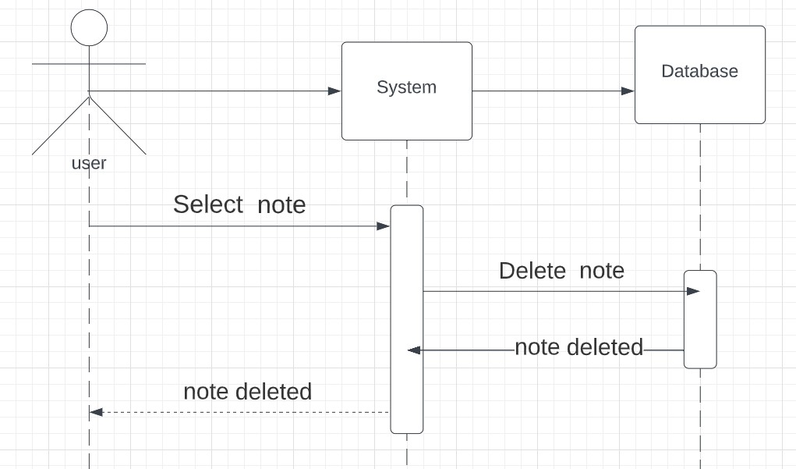

* **Tasks**

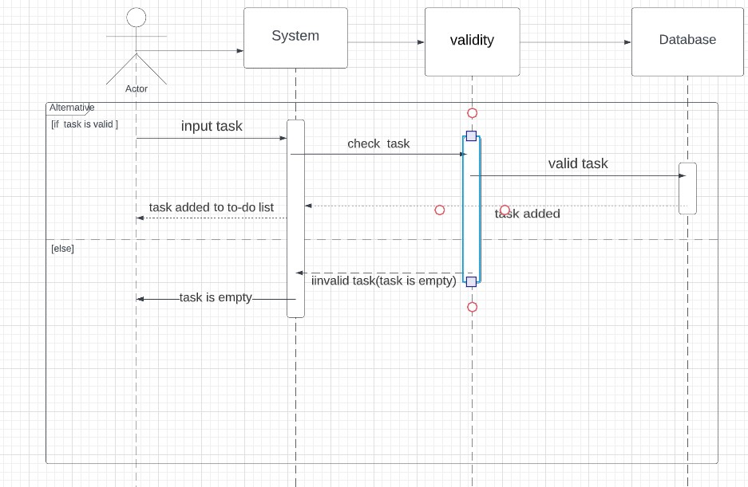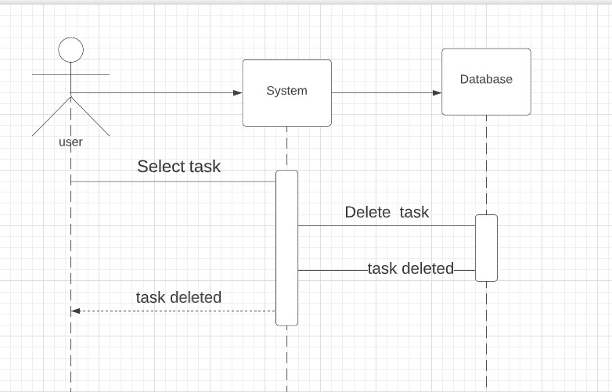

* **Random Activity**

